**PRESTIGE SCHOOL**

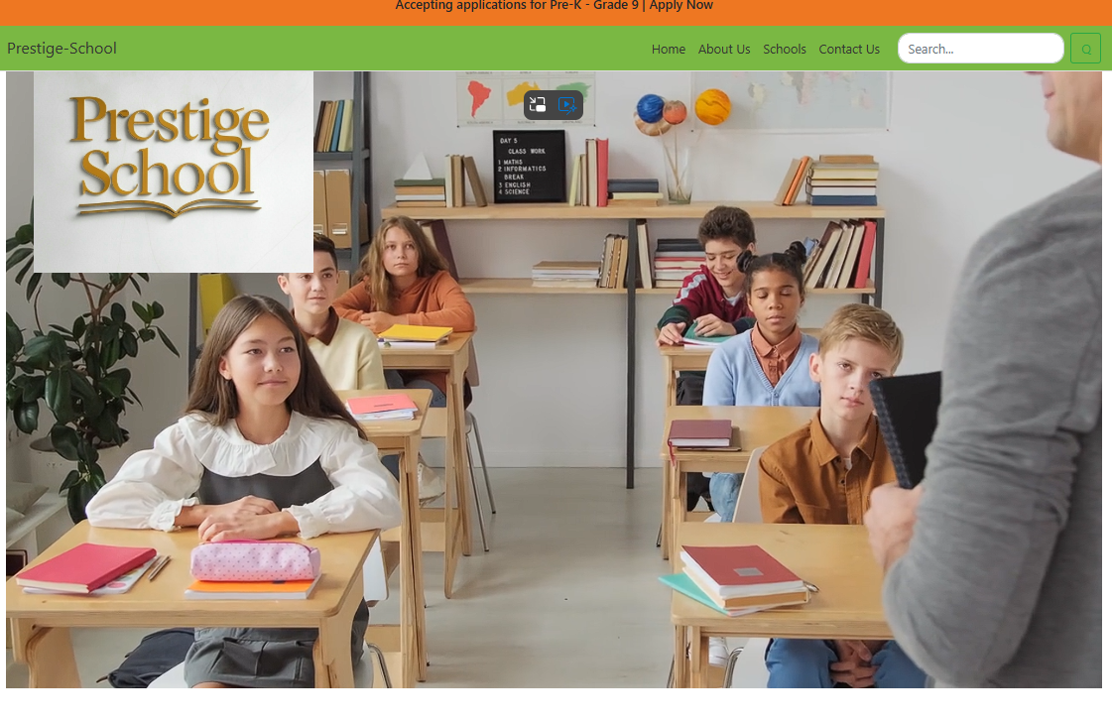

|  |  |  |
| --- | --- | --- |
| **Supervisor** | SIR FARHAN ALI | |
| **Batch** | 2410G2 | |
| **Group** | **B** | |
| **Serial No.** | **Enrollment Number** | **Student Name** |
| 1. | *Student1612774* | MUHAMMAD YOUSUF |
| 2. | *Student1612791* | MUHAMMAD BILAL SALEEM |
| 3. | *Student1613967* | RAHAT AZEEM |
| 4. | *Student1617163* | SALMAN KHAN |

# Problem Statement:

Finding a school as per everyone’s choice is now a days is very essential and confusing as there are many schools in and around the city. Visiting each and every school physically and getting information is really very difficult. Hence concept of developing “**SchoolsInfo”** seems very much needed. SchoolsInfo is a website which provides the information about the various schools available in the city. People who are interested in seeking admission for their kids can view this website where they can get to know where all the schools are situated and what all other facilities are available in that particular school.

Currently people generally find out the details about the schools from relatives/friends or visiting schools personally. But this is becoming difficult as many new schools are being established everywhere. Thus this can be overcome by the proposed system called “SchoolsInfo” where viewing all schools and related information in particular area from anywhere.

You are supposed to create a website for them with the below mentioned requirement specifications.

The website is to be developed for the Windows Platform using HTML5, JavaScript and Geolocation. The site should work well in all leading browsers including Chrome, IE, Firefox etc.

# Requirement Specification:

The Web site is to be created based on the following requirements.

1. The Home Page should be created making use of Sections with a suitable logo, the header section can be added which will show related images.
2. The site must contain the links to navigate through any category for the information.
3. The site should display a menu which will contain the options for brief introduction about the various schools , location and any other information if required.
4. The web site should also provide the option of searching the schools based on location and facilities.
5. Also have a Site Map option where viewers can see which all schools are available in our web site and can easily know where it is situated in the city. Their location should be displayed using GeoLocation API (eg. GoogleMaps)
6. The information about the school should include following major details

* + What is the maximum intake capacity of students?
  + Whether library is available
  + Availability of canteen facility
  + Availability of boarding
  + What type of sports options available

1. A brief summary of a particular school including list of facilities available, should be displayed on the Web Page along with the pictures but detailed features should be stored in individual Word documents which can be downloaded or viewed by the User who wishes to see the same.

**Acknowledgment:**

"We would like to acknowledge the continuous support and efforts of our dedicated teachers, students, staff, and parents at Prestige School. Their hard work and commitment play a vital role in creating a positive and enriching learning environment. We are thankful for the trust and collaboration that helps our school thrive and grow every day."

**Synopsis:**

**Introduction:**

"Prestige School is a leading educational institution committed to providing high-quality education in a nurturing and supportive environment. With a focus on academic excellence, personal growth, and character development, we aim to empower students to reach their full potential. Our dedicated staff, modern facilities, and student-centered approach create a strong foundation for lifelong learning and success."

**User Interface:**

"Prestige School offers a user-friendly interface for students, parents, and staff to access important information easily. The website is designed to provide a seamless experience with features such as online admissions, class schedules, updates on school events, and resources for both students and teachers. It’s simple to navigate, ensuring everyone stays connected and informed about school activities and important announcements."

**Conclusion:**

"In conclusion, Prestige School is dedicated to providing a high-quality education in a caring and supportive environment. We focus on the holistic development of each student, helping them grow academically, socially, and personally. With the support of our skilled staff, modern facilities, and strong community, we strive to inspire a love for learning and prepare our students for a successful future."

**Hero Section:**



**Navbar:**

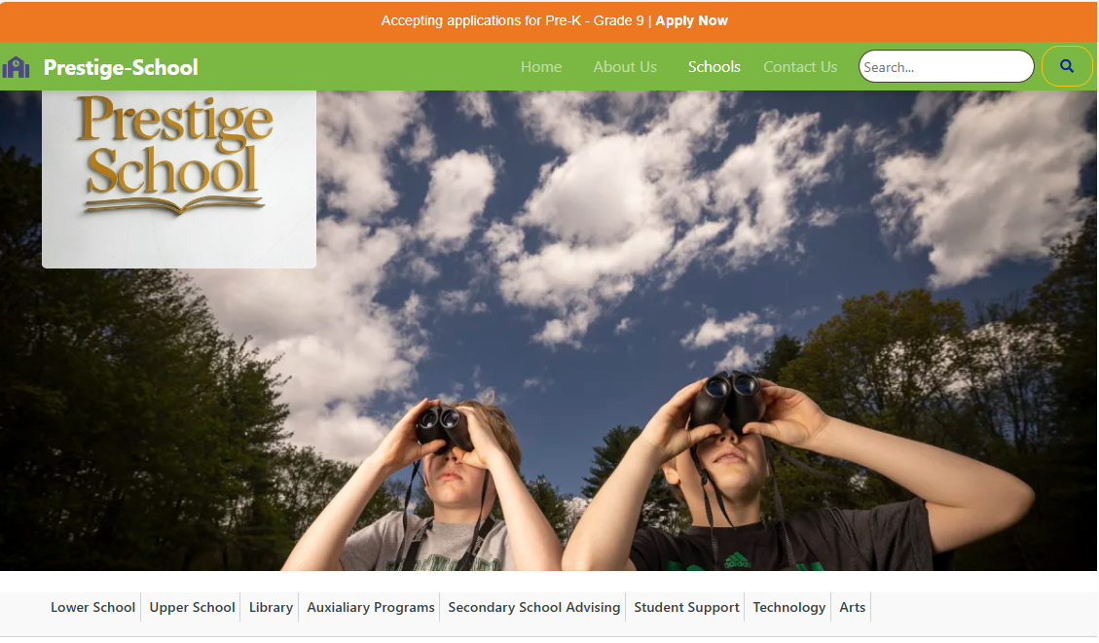

There are four essentials listed here, and you will be redirected to all the pages, which are further classified as:

* **HOME:** Explore the latest and attractive valuable website and top schools under it.
* **SCHOOLS:** Join our community and access exclusive features by looking forward.
* **ABOUT US:** Learn more about prestige-school - our mission, vision, and values.
* **CONTACT:** Reach out to us for inquiries, feedback, or collaborations.

**About Us:**

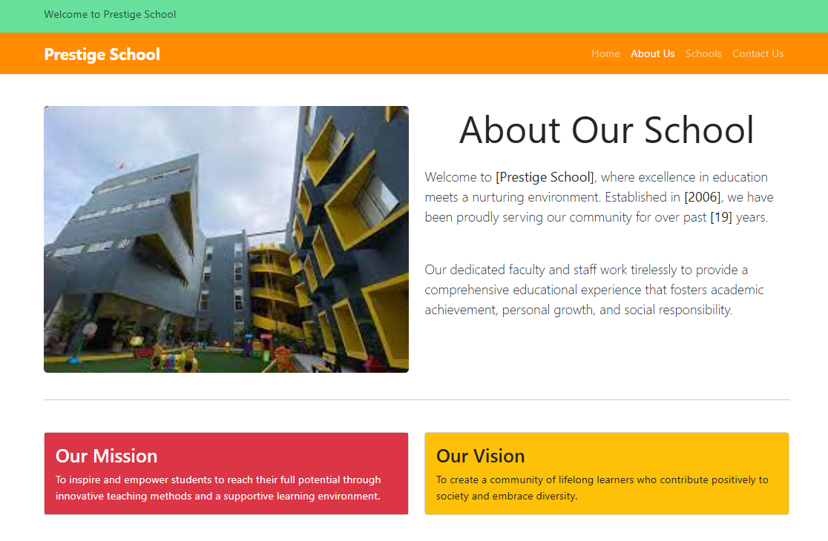

The "About Us" section of a prestigious school’s website provides important information about the school’s history, values, and mission. It explains what the school stands for, its commitment to providing high-quality education, and how it helps students succeed. This section often highlights the school’s achievements, its experienced teachers, and the unique programs or facilities it offers. It also shares the school’s vision for the future and the kind of environment it creates for students to grow academically, socially, and personally. The "About Us" section helps visitors understand why the school is well-respected and what makes it special.

**Today In World:**

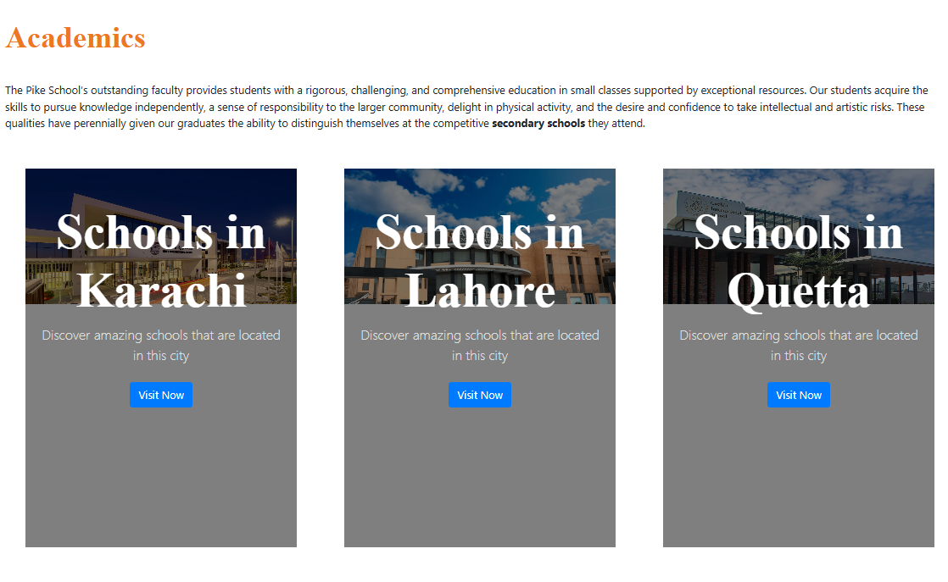

A prestigious school may have different types of programs or educational levels. These can include:

1. **Early Education:** This program focuses on the foundation of learning for young children, helping them develop basic skills in subjects like reading, writing, and math.
2. **Advanced Education:** This level provides more challenging subjects and prepares students for further education or their careers. Students can choose courses based on their interests and career goals.
3. **Global Programs:** Some prestigious institutions offer programs that follow international curriculums, providing a more global perspective and preparing students for global opportunities.

different programs are designed to meet the needs of students at various stages of their education, offering opportunities for growth and success.

**Footer:** 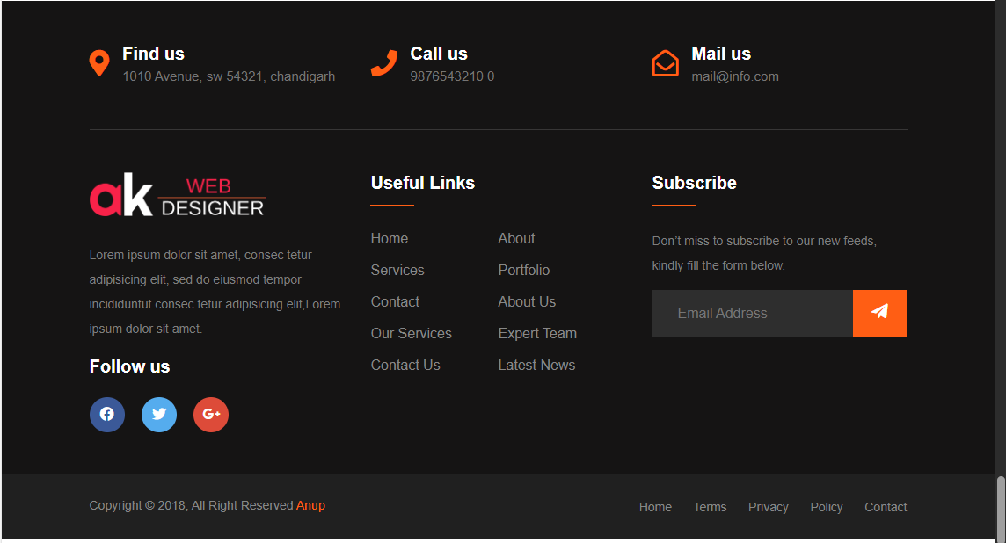

The footer of a prestigious school’s website is the section found at the bottom of the page. It usually contains important links, like contact information, social media profiles, school policies, and sometimes a brief about the school's mission or history. It may also include links to apply for admission, recent news, and other helpful resources. The footer helps visitors quickly find key details without needing to scroll through the entire website.

**Task Sheet Review:**

|  |  |  |  |  |  |  |
| --- | --- | --- | --- | --- | --- | --- |
|  | | **Project Title** | **Date of Preparation of Activity Plan** | | | |
| No. | **Task** | Prestige School | Actual | Actual | Name | Status |
| Start date | Days |
| 1 | Navbar & Footer | Prestige School | 18/Feb/25 | 1 | Yousuf & Bilal | Complete |
| 2 | Build Home Page | Prestige School | 21/ Feb /25 | 3 | Bilal & Yousuf & Rahat | Complete |
| 3 | Build Todays In School page | Prestige School | 22/ Feb /25 | 1 | Bilal | Complete |
| 4 | Build About Us Page | Prestige School | 25/ Feb /25 | 1 | Bilal | Complete |
| 5 | Build Contact Us | Prestige School | 28/ Feb /25 | 2 | Yousuf | Complete |
| 6 | Build Cards | Prestige School | 2/ March /25 | 2 | Rahat | Complete |
| 7 | Build detailed Page | Prestige School | 4/ March/25 | 2 | Bilal | Complete |
| 8 | Build Testimonial | Prestige School | 6/ March /25 | 2 | Yousuf | Complete |
| 9 | Build Search Button | Prestige School | 10/ March /25 | 2 | Rahat | Complete |
| 10 | Overview pages | Prestige School | 12/ March /25 | 1 | Bilal & Yousuf & Rahat | Complete |
| 11 | Layout Set | Prestige School | 16/ March /25 | 4 | Bilal & Yousuf & Rahat | Complete |

**Summary:**

A prestigious school is a highly respected and well-known educational institution that is recognized for its high academic standards, excellent teaching, and successful students. These schools usually offer a challenging curriculum and have experienced, skilled teachers. They are known for producing graduates who go on to achieve great success in their careers. Students at prestigious schools often have access to better resources, facilities, and extracurricular activities. Admission to these schools can be competitive, and they are often considered to provide an education that opens doors to future opportunities.